SSCC Numbering

The Pack number field follows the SSCC numbering scheme.

# SSCC-18 Format

*Sourced from https://www.gs1-128.info/sscc-18/*

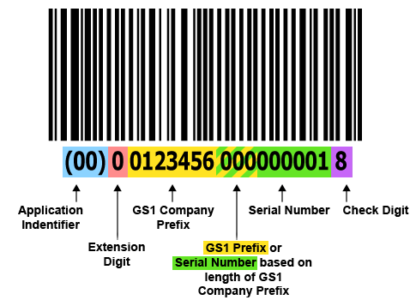

## Application Identifier (AI)

The AI “00” indicates the SSCC-18 data structure will follow.

## Extension Digit

The Extension Digit has no defined logic and is used to increase the capacity of the Serial Reference

## GS1 Company Prefix

GS1 Company Prefixes are 7-10 digits. Serial Reference Numbers are 6-9 digits.

## Serial Reference

The Serial Reference number is assigned by the holder of the GS1 Company Prefix to uniquely identify a shipping container (logistic unit). A Serial Reference cannot be reused for a minimum of 12 months. The combined length of the GS1 Company Prefix and Serial Reference is always 16 digits.

## Check Digit

Calculated using the Modulo 10 algorithm. Use a free [Check Digit Calculator](https://www.barcode.graphics/check-digit-calculator/) offered by Bar Code Graphics.

# TECSYS

## Shipping Container

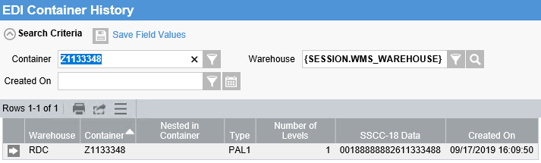

## Breakdown

|  |  |  |
| --- | --- | --- |
| SSCC-18 | 00188888882611333488 |  |
| Application Code | 00 | Always 00 |
| Extension Digit | 1 | 1 or 0  Set by Container: EDI Package Type  1 = Pallet  0 = Case / Carton |
| GS1 Company Prefix | 8888888 | Assigned by GS1  Set in Warehouse Options  Today, in production, this is blank, so this is not part of the SSCC today. |
| Serial Number | 261133348 | Consists of two part:   * First two digits are a numeric representation of the leading character of the Container number (01 = A… 26 = Z). In this case, the container starts with Z, so the first two digits are 26. * The last 7 digits are the last 7 digits of the Container number |
| Check Digit | 8 | Calculated based on preceding digits |

## Examples

Current State, without GS1 Company Prefix defined:

|  |  |  |  |
| --- | --- | --- | --- |
| Container | Container Type | SSCC | Note |
| A0123456 | Box | 00101234569 | The check digit in this example was not calculated |
| Z1133348 | Box | 02611333482 | The check digit in this example was not calculated |
| Z1133348 | Pallet | 12611333481 | The check digit in this example was not calculated |

## Impact

The SSCC value is moved into the Pack field on the ASN. The Pack is prefixed with “00”.

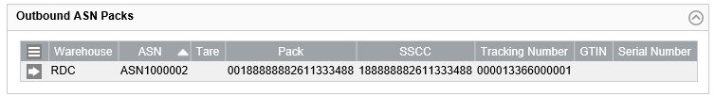

Note: The expectation would be for the SSCC to have the “00” prefix application code.

# Container Type – EDI Packaging Type

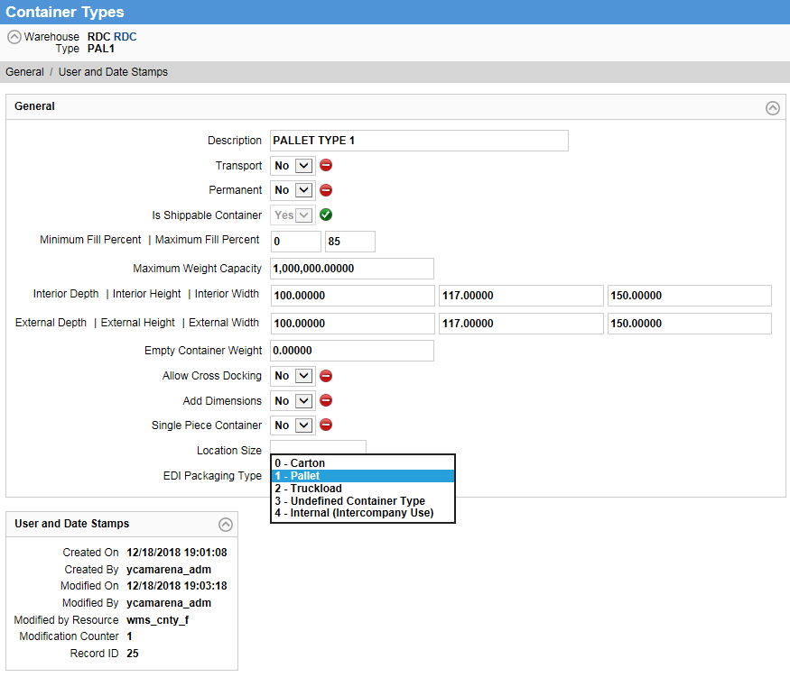

|  |  |
| --- | --- |
| EDI Packaging Type | The following options are available: 0 - Carton (default), 1 - Pallet, 2 - Truckload, 3 - Undefined Container Type, and 4 - Internal (Intercompany Use).  This value is used to identify the packaging type of EDI shipping containers. Used for the UCC128 bar code number creation. This value represents the **third character prefix of the UCC128**. |

Only Pallet is set to 1 - Pallet. All others are 0 – Carton.

# Warehouse Options: Company Prefix

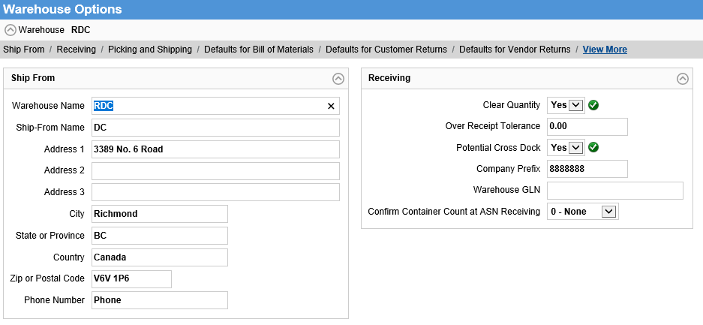

* Currently set to <blank>
* Set to 8888888 for illustration purposes in this case